1. DNA structure, function
2. RNA structure, function, types
3. Nucleosides and nucleotides
4. DNA replication
5. DNA dactyloscopy or DNA profiling what is this? Explain
6. Transcription
7. Learn following structures:
8. Purine and pyrimidine bases

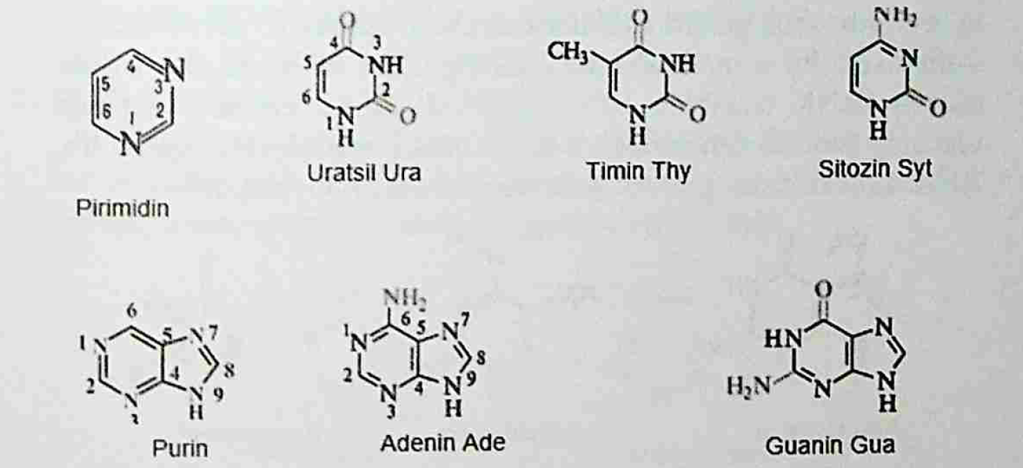

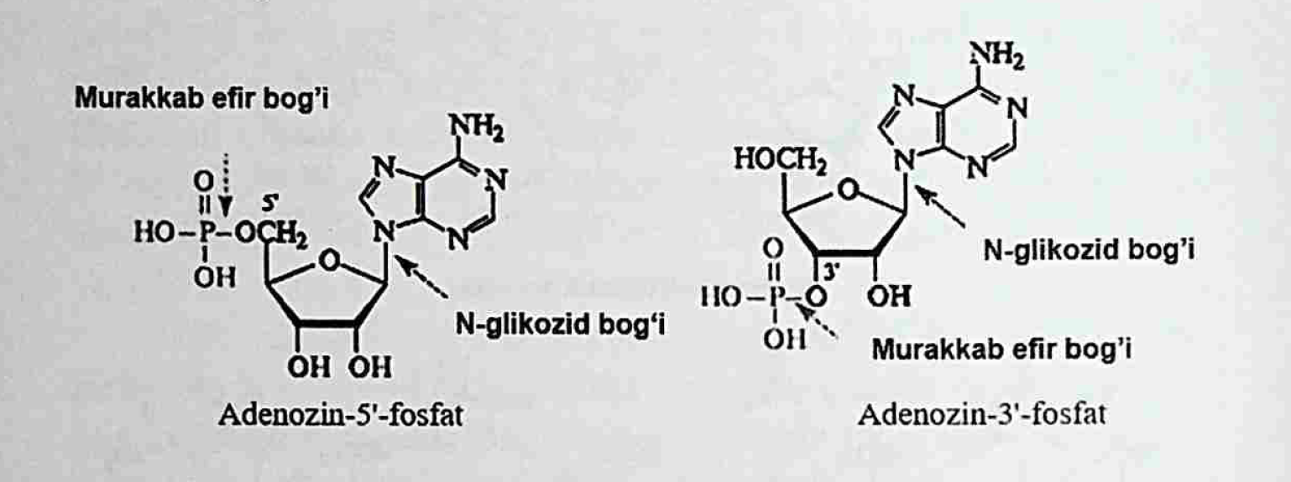

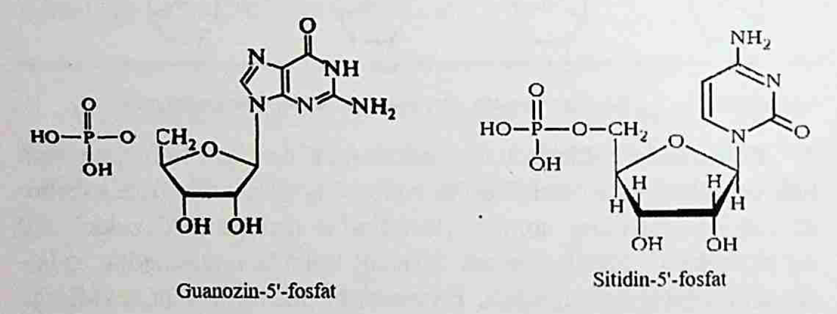

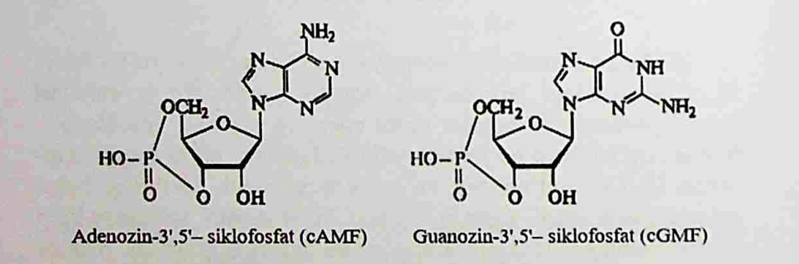

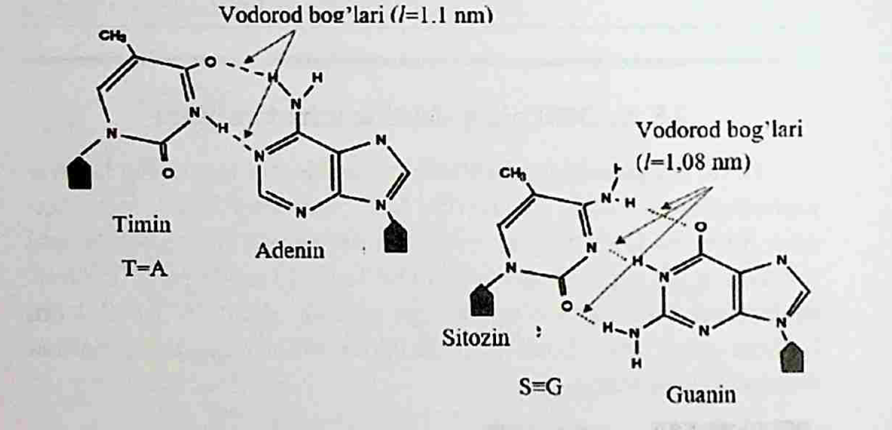

1. Learn structure of DNA and RNA
2. GIVE ATTENTION TO BONDINGS IN DNA